EMPATHIZE AND DISCOVER

* Empathy is the foundation of human-centered design. The problems you’re trying to solve are rarely your own, they’re those of particular users. Build empathy for your users by learning their values. To empathize, you:

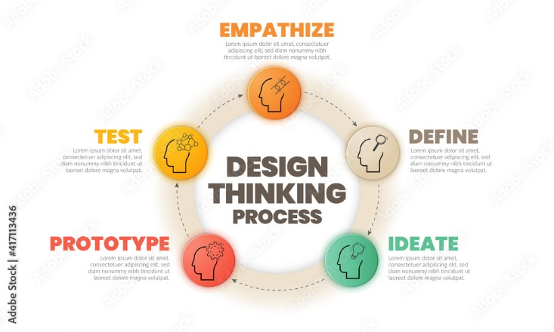

Observe

* Observehow users interact with their environment. Capture quotes, behaviours and other notes that reflect their experience. Watching users gives you clues as to what they think and feel – what they need.

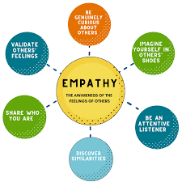

#### Engage

* Interact with and interview users through both scheduled and short ‘intercept’ encounters.
* Engage users directly—interact with and interview them. Engaging users reveals deeper insights into their beliefs and values.

#### Immerse

* Immerse yourself in your users’ experience. Find (or create if necessary) ways to immerse yourself in specific environments to understand first hand who you’re designing for.
* The best solutions come from the best insights into human behavior. Discover the emotions that drive user behavior. Uncover user needs (which they may or may not be aware of). Identify the right users to design for. Use your insights to design innovative solutions.